“GameNet.com”

Frostburg State University Retro Gaming Website

## SCIA 325-001 Software Security Engineering

**Table of Contents**

**Brief Description.......................................................................................................................... 3**

**Team Members and Responsibilities.......................................................................................... 3**

**Framework and Resources.......................................................................................................... 3**

**Environment and Programming Language............................................................................... 4**

**Tentative Games........................................................................................................................... 4**

**Website.......................................................................................................................................... 4**

* Website Hosting................................................................................................................. 6

**Games............................................................................................................................................ 6**

* Bar Bounce........................................................................................................................ 6
* Serpent............................................................................................................................... 7
* Table Tennis....................................................................................................................... 7

**Legal and Copyright Implications.............................................................................................. 8**

**References..................................................................................................................................... 8**

**Brief Description**

Ever want to blow off some steam or just sit back and enjoy vintage arcade games for free? Well, GameNet is the site for you. Our target audience is kids, students, people who just want to have fun, those bored at work or just need something to do. Our goal is to create a website that will host different arcade based javascript GUI games that we create.

**Team Members and Responsibilities**

The group has four members. Jericho Yantz is responsible for making and hosting the website. Zayd Sani is responsible for creating a multiplayer pong game. Nicholas Richardson is responsible for creating a snake style game. Nathan Turner is responsible for creating a mini-tennis ball game. Zayd, Nicholas, and Nathan will make more games if time allows and assist Jericho with the website if needed.

**Framework and Resources**

The members making the games will use Eclipse IDE to write the javascript for their respective games. The games will be GUIs coded with Java. Visual Studio Code will be used for file editing. Unsplash photos is where we will obtain copyright-free pictures for the website. Microsoft Teams will be our main resource for group communication. We will upload files, host meetings, and have group discussions in Teams. A slack.com is used for sharing the group members’ code online.

**Environment and Programming Language**

The main programming language we will use will be Java to make the GUI games. Eclipse IDE was chosen due to it being the most familiar IDE in the group. The website will use HTML5 & CSS3.

**Tentative Games**

* Table Tennis
* Serpent
* Bar Bounce

**Website**

Below are screenshots of the tentative layout of our website.

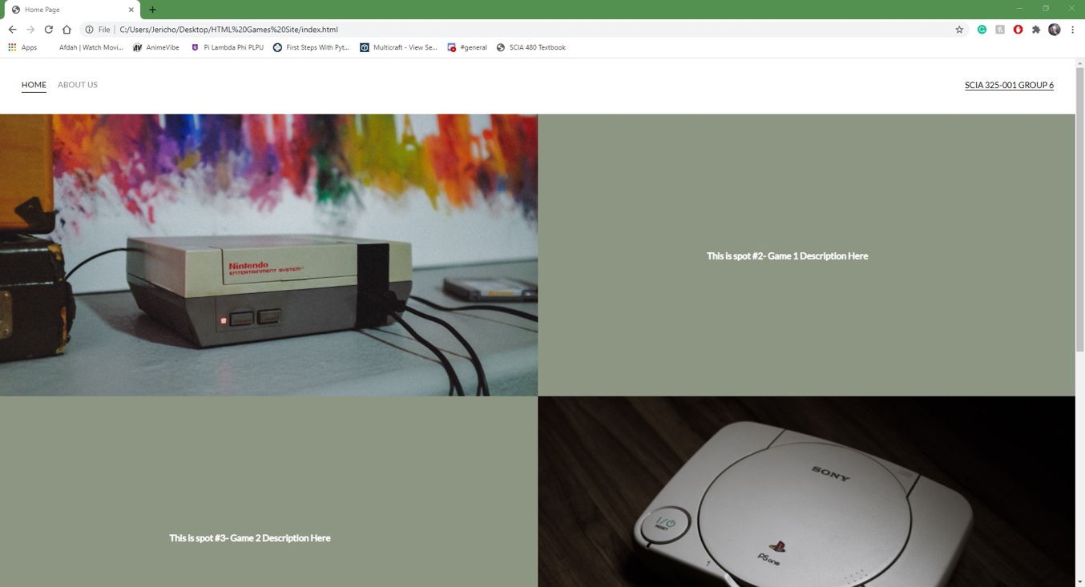

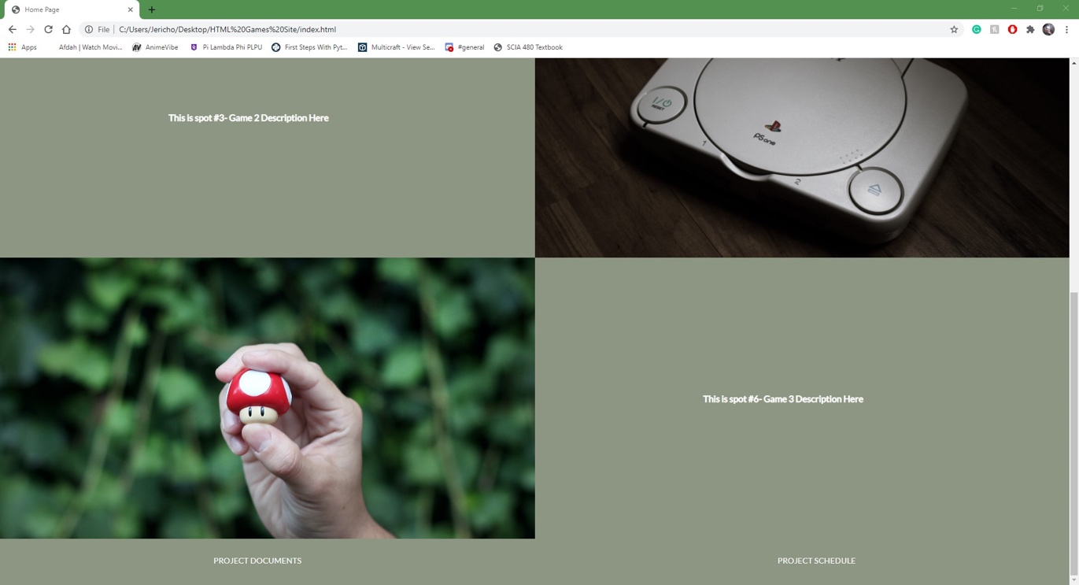

Pictured above is what we are planning the “Home” page of our website to look like. The images are subject to change as of now, but there is a link embedded within the pictures that appears when the user hovers the mouse close enough. The links are functional, but the games have not been uploaded to the site as of yet. The spaces next to the picture will contain a brief description of the games. This functions to allow users to more easily decide what they would like to play.

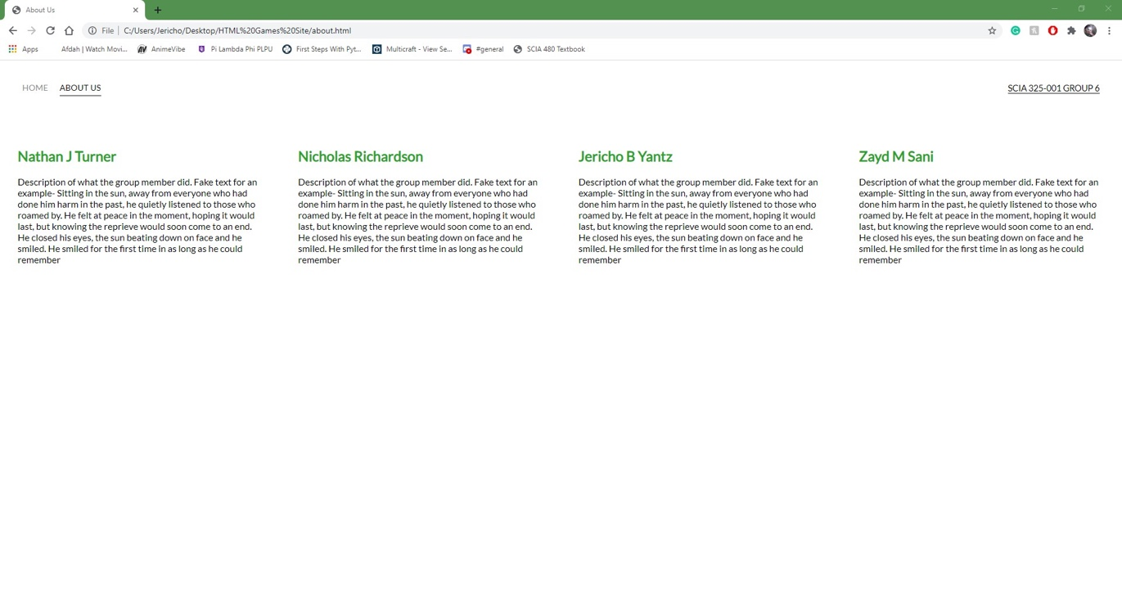Pictured below is the design of our “About Us” page. This will contain any information we wish to share about ourselves as well as what our part of the project entailed. As of now, it is filled with filler text to help picture the layout of the page better.

The other pages our website will contain will be a “Schedule” page, for the project schedule/timeline to be held, and then a “Documents” page. The “Documents” page will contain all of the proposals, presentations, and any other documentation that our group may complete for this project (including this proposal).

**Website Hosting**

Using GitHub Pages, we should be able to host our Arcade Game style website for free. GitHub offers an easy-to-use experience, that allows for learning and code sharing, all for free.

**Games**

* **Bar Bounce**

Bar Bounce is a single player game where the player has to keep a ball above the line that the player controls with the left and right arrow keys. The game will end when the player can't hit the ball in time and the ball falls behind the player’s controlling bar. The unique and challenging aspect is that we designed the game to casually speed up as the game progresses to make the game more fun for the player. The game will have a counter in the top corner to designate the score.



Simple preview of GUI game of Bar Bounce

mm

* **Serpent**

Serpent is a single player game where the goal of the game is to eat as much food as possible to grow before hitting an undesired object. The game consists of a snake and bits of “food” on the screen. Each time the snake eats the food, it will grow one bit longer, eventually resembling a snake. The snake however cannot run into the sides of the screen or its long tail. If the snake hits these undesired areas, the game will be over.

Intended look of GUI Serpent Game

* **Table Tennis**

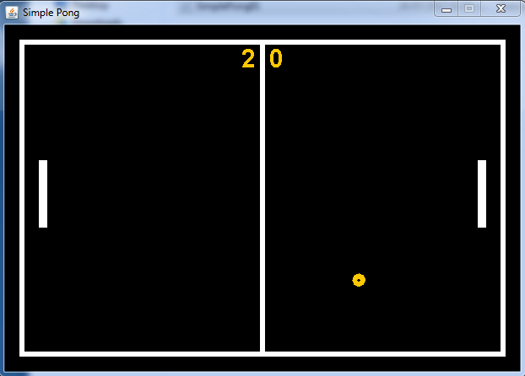Table Tennis is a “pong” style multiplayer game. It is intended to be played by two people on the same computer. Each player will have a paddle and their goal is to hit the ball past the other player’s paddle and into the scoring zone. Player one will use the up and down arrow keys to move their paddle, while player two will use the “W” and “S” keys to move their paddle up and down. The player who gets to 7 points first wins the game.

Intended look of GUI Table Tennis

**Timeline and Schedule**

We are going to try to meet twice a week outside of class, specifically Mondays and Fridays at 2:00 pm. Our tentative schedule for completing the project is as following:

* March 8: 1st midterm presentation
* April 2: 2nd midterm presentation
* April 23: End of semester presentation
* April 28: Design documentation sheet

**Legal and Copyright Implications**

Since we are imitating popular games in our code, we have to legally change the name of some of them to avoid copyright infringement. According to theamericanbar.com, “The system or processes that make up the core of a game—generally referred to as the ‘game mechanics’—are not subject to copyright.” Atari owns the name to “Pong” but does not own the game mechanics since the mechanics are not uniquely identifiable to “Pong.” Since we are making the game mechanics ourselves and Atari does not own tennis style games, we can create a tennis game and call it “Table Tennis” and not infringe on the copyright. The same principle goes for the “Snake” style game, so we changed it to “Serpent.”

**References**

www.theamericanbar.com